Huon Valley Hub
Exhibition Space

The Huon Valley Hub exhibition space is on 23 Main Street, Huonville. It is available to all artists in the Valley and supports community arts, creative and cultural projects.

Expressions of Interest

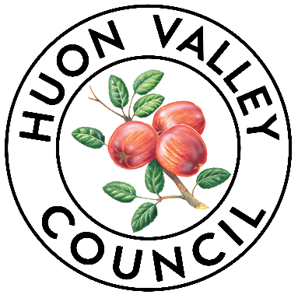

For enquiries please contact:
Huon Valley Council
Arts and Culture Officer
E: hvc@huonvalley.tas.gov.au
T: (03) 6264 0300

HUON VALLEY HUB EXHIBITION SPACE – EXPRESSION OF INTEREST
Please submit your completed Expression of Interest (EOI) to hvc@huonvalley.tas.gov.au.
The Huon Valley Council welcomes EOIs from artists (established and emerging), curators, art groups and arts organisations.
You can choose a month for your exhibition.
Artists cannot sell directly though the Huon Valley Hub exhibition space, but you can provide contact details and link to social media where you can provide information of any artworks on display.
Please read and agree to the Huon Valley Hub Exhibition Conditions of Hire before submitting an EOI.
Exhibitions must satisfy at least one of the following criteria to be eligible. It:
- Provides a platform for the Huon Valley community to own, express and share their stories, heritage, experiences, and dreams.
- Celebrates the Huon Valley.
- Celebrates difference, diversity and understanding within/between communities.
- Promotes learning or skills development (either for the audience or yourself).
- Has an impact on audiences or draws new audiences.
- Is innovative and/or original in its concept.
If you have any questions or need assistance with the application process, contact the Arts & Culture Officer at hvc@huonvalley.tas.gov.au, or call 6264 0300.

Please note: Incomplete applications will not be considered.

ABOUT YOU

Name of Exhibition:

Are you an:
□ Individual artist
□ Group
□ Organisation

Name of main contact person:

Main contact email:

Main contact phone:

Address:

ABOUT YOUR EXHIBITION

How many artists does your exhibition involve:

Describe your proposed exhibition (max 200 words):

What is the status of your exhibition at the time of this application?
□ This is a finished series of works
□ This is a work still in development

What is your preferred Month/Year?

Would you like to run a public program (artist talk, workshop or other) to accompany your exhibition?
□ Yes
□ No

SUPPORT MATERIAL
Please provide examples of your work.
We prefer examples of current work that will be included in your exhibition. Examples of past work which demonstrate your art practice are also acceptable.
Examples of work can be provided as:
- Individual Images.
- A word document or PDF with several images/links.
- A link to a website, YouTube, Vimeo etc (please link to the page of relevance, not a general website link).
Max of 10MB per submission
Please list the files or images you have uploaded (for artworks include the title, year, medium, scale) and briefly indicate their relevance to your proposal (max 200 words):

List URLs/weblinks and briefly indicate their relevance to your application (max 200 words):

HUON VALLEY HUB EXHIBITION SPACE - CONDITIONS OF HIRE
The Huon Valley Hub exhibition space - Conditions of Hire is a separate document with further information about the space and conditions of hire. You need to read and agree to these conditions before we consider your application to exhibit in the Huon Valley Hub.
By submitting this form, you acknowledge that you have read the Huon Valley Hub exhibition space - Conditions of Hire and that you agree to those conditions should your expression of interest be accepted.

I,
acknowledge having received, read, and accepted the Huon Valley Hub exhibition space - Conditions of Hire.

Applicant Signature: ________________________ Date: _______________

That’s it!
Please note that registering your interest does not guarantee a spot in the Huon Valley Hub. All applications are subject to availability and will be reviewed by a panel to determine their suitability for presentation in the Huon Valley Hub.

Do you have any questions or need assistance with the application process? Contact the Arts & Culture Officer at hvc@huonvalley.tas.gov.au or call 6264 0300.

Please submit completed applications for consideration.

